ENGLISH CLASS
PAST CONTINUOUS
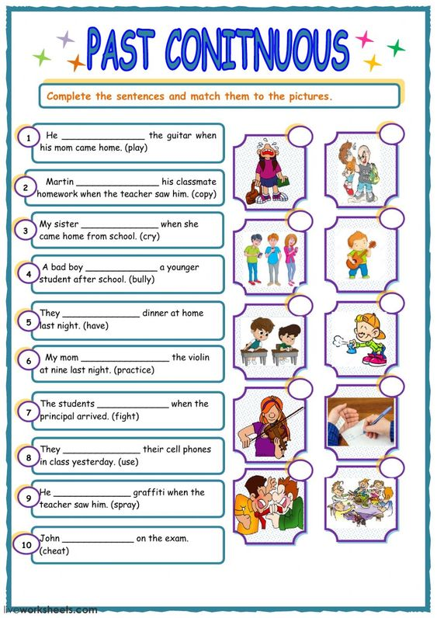
Active voice

