
EES N° ...................................... Class: 1° Año
Teacher: González Natalia Alumno/a:........................................
Mail: panaca08@gmail.com Fecha de Entrega: 8 de Julio de 2021
TRABAJO PRÁCTICO INTEGRADOR-Julio 2021

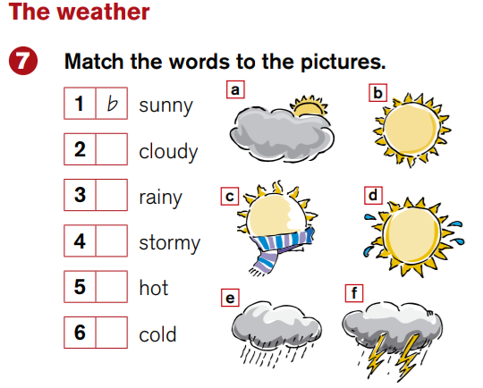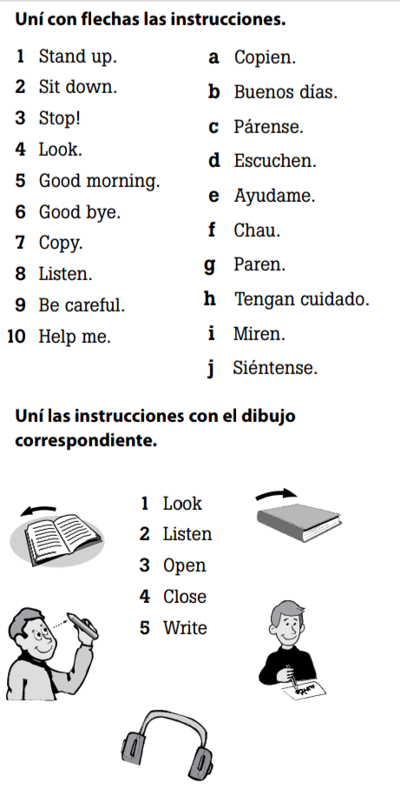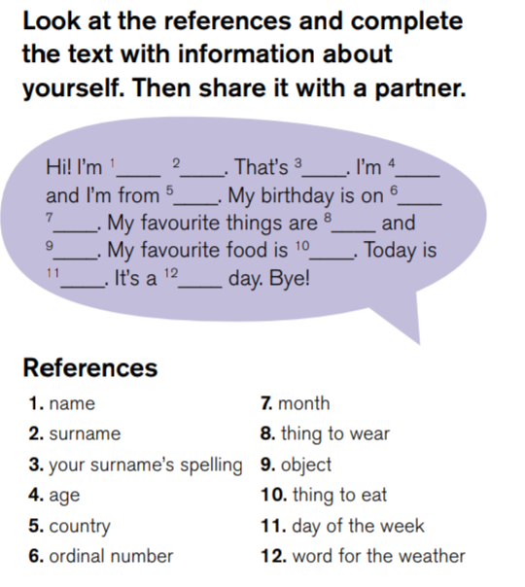

PERSONAL INFORMATION: This is me!
Name:..........................
Surname:............................
spell Full name:..............................
Age:...................................
Birthday:.........................................................
Country:...................................
Nationality:....................................
Telephone number:.........................................
Address: ........................................................
Email:...............................................................

Personal

