Practise
Look at the pictures and answer the questions. (Mira las imágenes y responde las preguntas)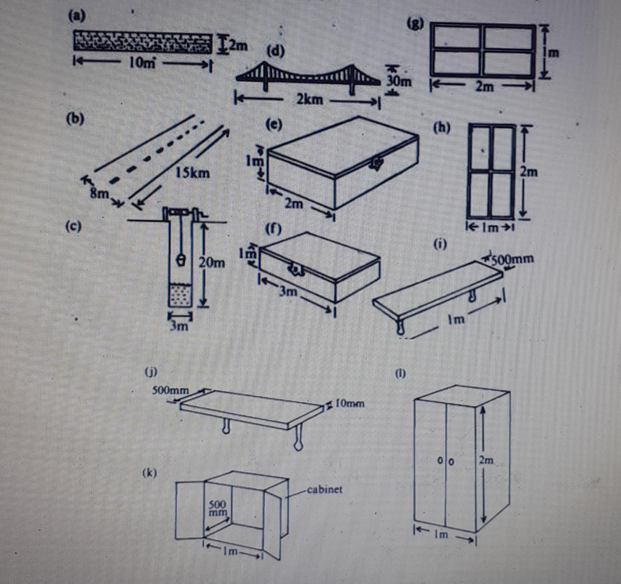
a-How long is the wall? It’s ten metres long
How high is it ? It’s two metres high
b- How long is the road ? _________________
How wide is it ? _________________
c- How deep is the well? _________________
How wide is it ? _________________
d- How long is the bridge? __________________
How high is it ? __________________
e-How wide is the box? __________________
How high is it? __________________
f-How long is the box? __________________
How high is it? __________________
g- How wide is the window?_________________
How high is it? __________________
h-How high is the door ? __________________
How wide is it? __________________
i-How long is the self? __________________
How thick is it? ___________________
j-How wide is the self? ___________________
How thick is it? ___________________
k-How wide is the box? ___________________
How deep is it? ___________________
l-How high is the cupboard?___________________
How wide is it? ____________________

