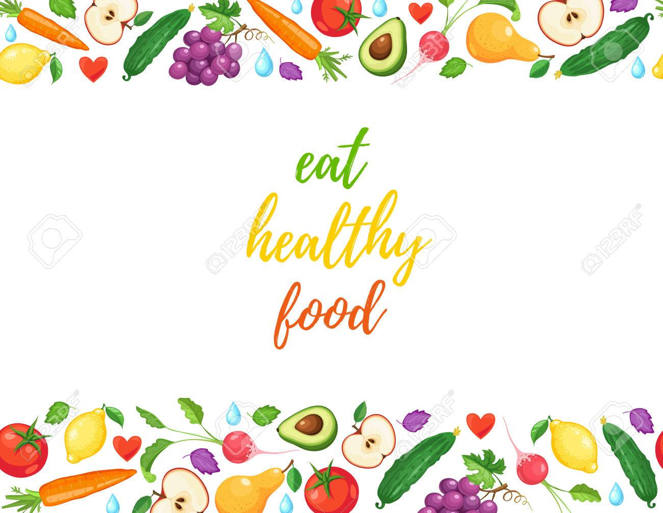

ESPACIO CURRICULAR: LENGUA EXTRANJERA: INGLÉS
ACTIVITY 3. Enviar esta actividad el día jueves 24 de junio.
Read and translate the following texts(Leer y traducir los siguientes textos . Para realizar la traducción, podés usar traductor o diccionario bilingüe.)
A good diet is an essential part of a healthy lifestyle for children, teenager and adult.Una Buena dieta es una parte esencial de un estilo de vida saludable para niños, adolescents y adultos.
What does our food give us? ¿Qué nos brinda nuestra comida?
1-VITAMINS: help us grow. They are important for our eyes, skin, bones and other parts of the body. Most fruits and vegetables are rich in vitamins.
Las vitaminas nos ayudan a crecer. Son importantes para nuestros ojos, huesos y otras partes del cuerpo. La mayoría de las frutas y vegetales son ricas en vitaminas.
2-MINERALS:make our bones and teeth strong. Milk, fruit and vegetables provide lots of important minerals.
3-FIBRE:cleans the inside of our body. We get fibre from fruits and vegetables, and from wholegrain bread, rice and pasta.
4-CARBOHYDRATES:give us bodies energy. Bread, pasta, rice, potatoes and cakes are sources of carbohydrate.
5-FATS:build muscles and provide lots of energy. They are essencial for a balanced diet, but we only need them in small quantities. A highly fat diet is bad for our skin and our heart,and can cause obesity. Most cheese, crisps and hamburgers are high in fat.
6-PROTEINS:help us grow and also give us energy. Meat, fish, eggs and cheese are good sources of protein.

