VOCABULARY: COUNTRIES AND NATIONALITIES

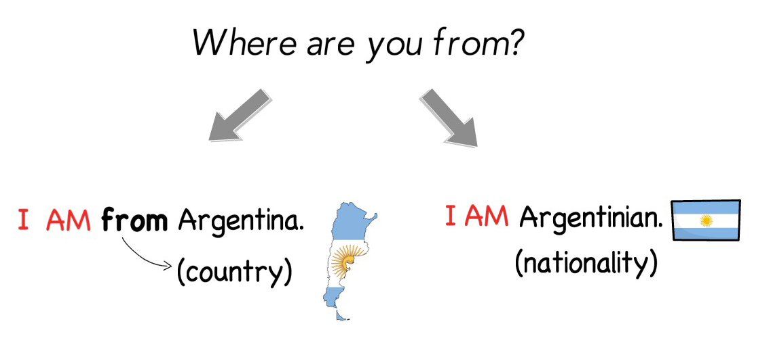
FLAG | COUNTRY | NATIONALITY ADJECTIVE
-an
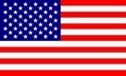 | United States of America  (US – USA) | American
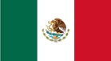 | Mexico | Mexican
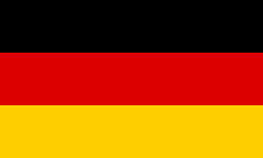 | Germany | German
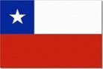 | Chile | Chilean
-ian
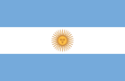 | Argentina | Argentinian
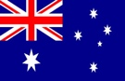 | Australia | Australian
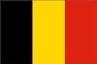 | Belgium | Belgian
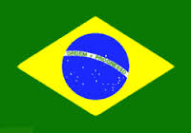 | Brazil | Brazilian
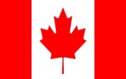 | Canada | Canadian
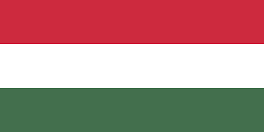 | Hungary | Hungarian
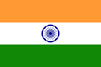 | India | Indian
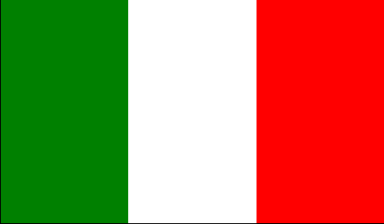 | Italia | Italian
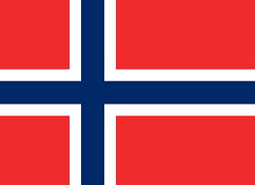 | Norway | Norwegian
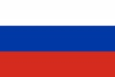 | Russia | Russian
-ish
 | United Kingdom | British
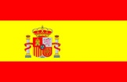 | Spain | Spanish
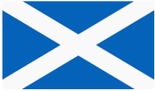 | Scotland | Scottish
 | Ireland | Irish
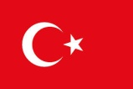 | Turkey | Turkish
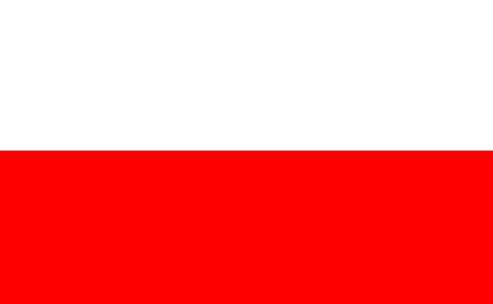 | Poland | Polish
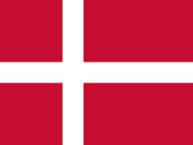 | Denmark | Danish
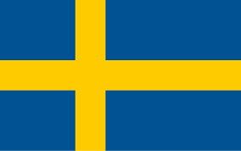 | Sweden | Swedish
-ese
 | China | Chinese
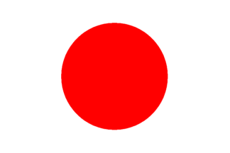 | Japan | Japanese
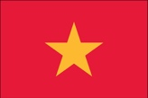 | Vietnam | Vietnamese
Irregular
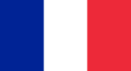 | France | French
 | Greece | Greek
 | Switzerland | Swiss
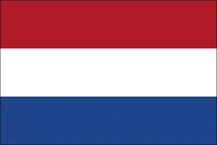 | The Netherlands | Dutch
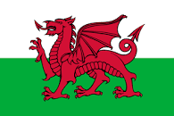 | Wales | Welsh

