ENGLISH CLASS
Passive and active voice
PRESENTE CONTINUO:
PASIVE VOICE
Estructura
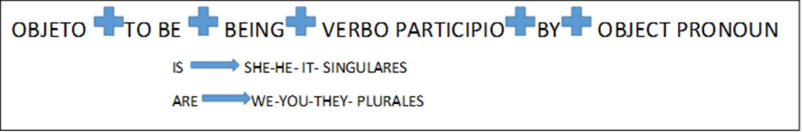
Examples:
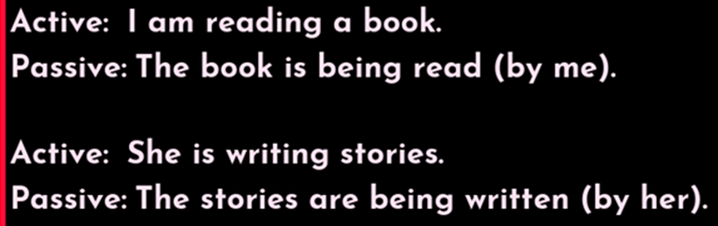

Practice:
-Complete with the active voice, and then pass them to Passive voice.
- She…………….a guitar today. (PLAY)
- We…………….to the radio now. (LISTEN)
- I………………..the exercises just now. (COMPLETE)
- He………….the flowers now.(WATER)
- My mother………..the dinner today. (MAKE)


