ENGLISH CLASS
Passive and active voice
PRESENTE CONTINUOUS:
PASIVE VOICE

Estructura
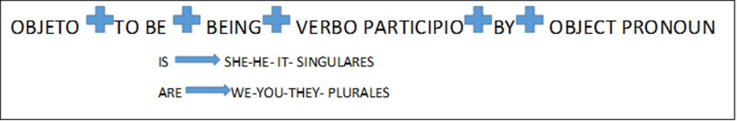
Examples:
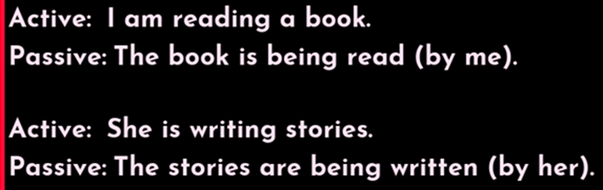

Practice:
-Complete with the active voice, and then pass them to Passive voice.
- We…………….a TV show now. (WATCH)
- He……………..the dishes at this moment. (WASH)
- I………………a message right now. (SEND)


