ENGLISH CLASS
Passive and active voice
PRESENTE SIMPLE:
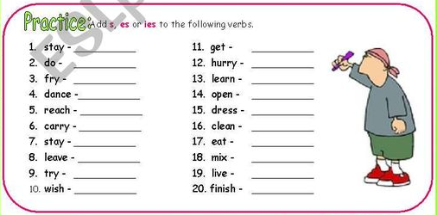

- Complete with the active voice, and then if you can pass them to Passive voice.

- My sister……………..with her little friend every day. (PLAY)
- They…………………crayons every year. (LOSE)
- She…………………..her practical work on Sunday. (FINISH)
- I…………………..early on Mondays. (GET UP)

PRESENTE CONTINUOUS:

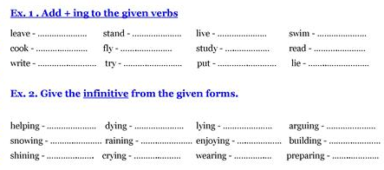

- Complete with the active voice, and then if you can pass them to Passive voice.

- She………………chess now. (PLAY)
- We…………….for the exam at this moment. (STUDY)
- They……………a new word in English right now. (KNOW)
- I………………..to bed late today. (GO)



