E.E.S N° 75 “JULIO CORTÁZAR”
Espacio Curricular: Lengua Extranjera: Inglés
Trabajo Practico N° 1
VOCABULARY (Vocabulario)

Course: 1° ……. Date:………………… Name:………………………………
Enviar las respuestas al siguiente correo:
1°3° - Profe. Patricia González: patitohope@gmail.com

TRABAJO PRACTICO N°5

Vocabulary - School Things

 calculator
 scissors
glue
bag
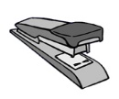stapler
blackboard
desk
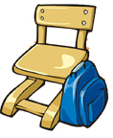chair
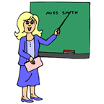teacher
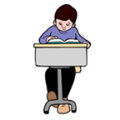student
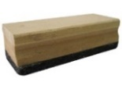 board eraser
 notebook
 pen
pencil
sharpener
marker
chalck
 eraser/rubber
 ruler

pencil case

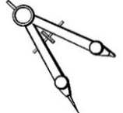compass

scotch tape/sellotape

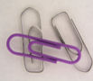clips
 computer
netbook
book
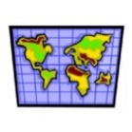 map

 sheets of paper

 door

 window

school
light

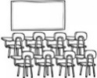 classroom

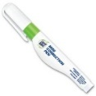 correction pen

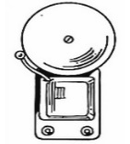 school bell

School Subjects
(Asignaturas escolares)

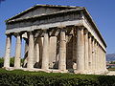History

Geography

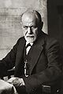Psychology
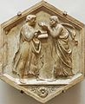Philosophy

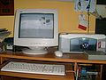 Technology

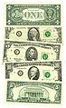Economics

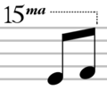Music
Drama

Chemistry

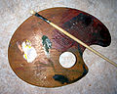Art

Physical education
Languages
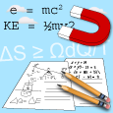Physics

Biology

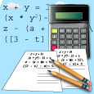 Maths

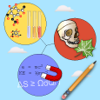Science

Name
Date:
Course: 1°

School objects
Exercises

1-Find the objects of the classroom from the box
WINDOW | DOOR | BELL
PAPER | MAP | NETBOOK
CHALK | BAG | STUDENT
NOTEBOOK | TEACHER | SCHOOL
LIGHT | PENCIL | PEN

P | E | N | C | I | L | I | G | H | T
B | H | D | R | P | A | P | E | R | S
E | T | N | E | W | I | N | D | O | W
L | M | E | H | S | U | S | H | P | I
L | M | T | C | T | A | C | M | G | C
E | E | B | A | U | C | H | A | L | K
Z | S | O | E | D | S | O | P | Y | R
S | N | O | T | E | B | O | O | K | B
A | A | K | I | N | N | L | X | Q | A
R | P | E | N | T | D | O | O | R | G

2- Make a drawing of the objects and paint them
Eg. Pencil 

……………………………… ……………………………… ………………………………

……………………………… ……………………………… ………………………………

……………………………… ……………………………… ………………………………

……………………………… ……………………………… ………………………………

……………………………… ……………………………… ………………………………

……………………………… ……………………………… ………………………………

Vocabulary
Days of the week

Sunday (Domingo)
Monday (Lunes)
Tuesday (Martes)
Wednesday (Miércoles)

Thursday (Jueves)
Friday (Viernes)
Saturday(Sábado)

Months of the year

January: Enero
February: Febrero
March: Marzo
April: Abril
May: Mayo
June: Junio
July: Julio
August: Agosto
September: Septiembre
October: Octubre
November: Noviembre
December:Deciembre

Seasons of the year

Summer: verano Winter. invierno
Autumn: otoño Spring: primavera

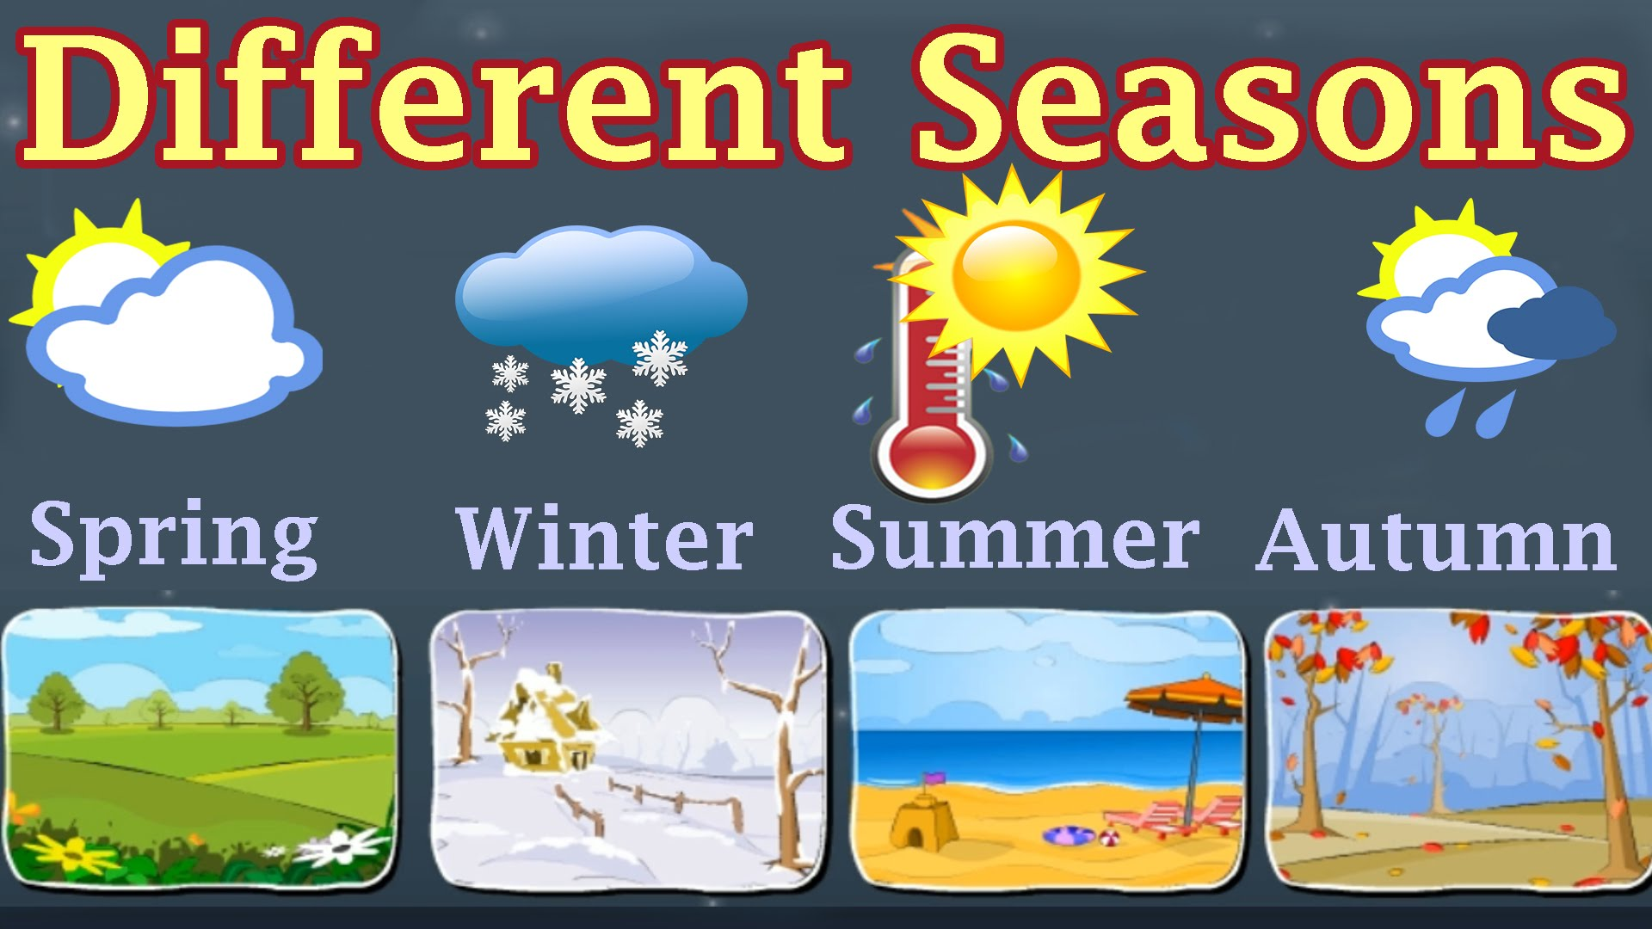

Espacio Curricular: Lengua Extranjera : Inglés I
Name
Date:
Course: 1°
Months of the year
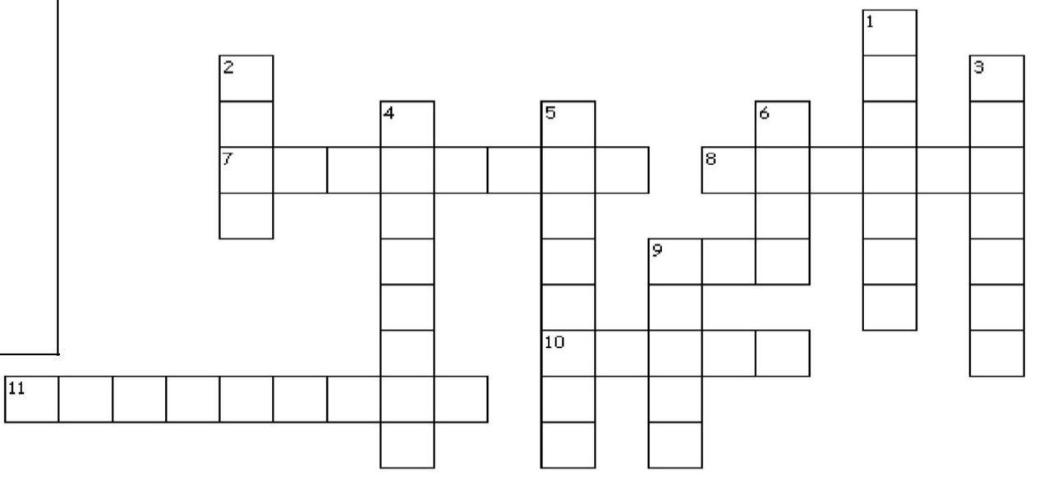
Exercises

Ordinal numbers (números ordinales)
1st –first 7th seventh
2nd-second 8th eighth
3rd –third 9th –ninth
4th –fourth 10th –tenth
5th –fifth 11th eleventh
6th –sixth 12th twelfth

Across
7._____________ is the eleventh month of the year.
8._____________is the eighth month of the year.
9.____________is the fifth month of the year.
10._____________ is the fourth month of the year.
11._______________ is the ninth month of the year.

Que día es? Ordena las letras  M d o a y n | ________________
T e d y u s a | ________________
W y d a d e n e s | ________________
T u h d y a r s | ________________
F y r a d i | ________________
S y a d a u t r | ________________
S y u a d n | ________________

.

Down
1.__________ is the first month of the year.
2.___________ is the sixth month of the year.
3.______________is the tenth month of the year.
4._____________ is the twelfth month of the year 5._____________is the second month of the year.
6._____________is the seventh month of the year.
Ordena los meses  September | 1)____________
August | 2)____________
January | 3)____________
March | 4)____________
June | 5)____________
December | 6)____________
July | 7)____________
February | 8)____________
October | 9)____________
May | 10)___________
April | 11)___________
November | 12)___________
9.__________________ is the third month of the year.

