PAST SIMPLE: REGULAR VERBS
GRAMMAR: Talking about the past actions.
Affirmative form:
EXAMPLES:
- I walked the dog yesterday. (Ayer saqué a pasear al perro)
- Sara lived in Rome. (Sara vivió en Roma)
- They stayed at home last week. (La semana pasada ellos estuvieron en casa)
- We studied for the exam all day. (Estudiamos para el examen todo el día)
- The bus stopped abruptly at the bus station. (El autobús se detuvo bruscamente en la parada)
RULES : Para que los verbos estén en pasado se debe agregar ed / d /ied de acuerdo a como termina la escritura del mismo.
EXAMPLE: VISIT (VISITAR) – VISITED (expresa la acción en pasado)
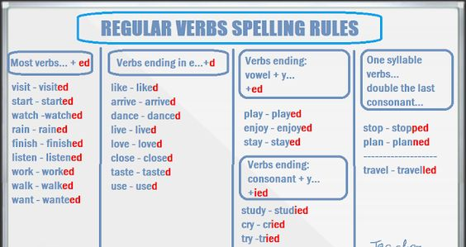

PERSON + INFINITIVE VERB +ED/D/IED + REST OF THE SENTENCES

PAST SIMPLE: REGULAR VERBS
NEGATIVE FORM
EXAMPLES:
- I didn´t walk the dog yesterday. (Ayer no saqué a pasear al perro)
- Sara didn´t live in Rome. (Sara no vivió en Roma)
- They didn´t stay at home last week. (La semana pasada ellos no estuvieron en casa)
- We didn´t study for the exam all day. (No estudiamos para el examen todo el día)
- The bus didn´t stop abruptly at the bus station. (El autobús no se detuvo bruscamente en la parada)

PERSON + DIDN´T + INFINITIVE VERB + REST OF THE SENTENCES

didn´t = did not

PAST SIMPLE: IRREGULAR VERBS
GRAMMAR: Talking about the past actions.
Affirmative form
EXAMPLES:
- I ...went...(go) to the supermarket yesterday. (Ayer fui al supermercado)
- Sara ….saw…(see) Peter in the disco. (Sara vió a Peter en la disco)
- They …lost…(lose) the match last Saturday. (El sábado pasado ellos perdieron el partido)
- We …did…(do) our homework in the morning. (Hicimos la tarea en la mañana)

PERSON + PAST SIMPLE COLUMN + REST OF THE SENTENCES

Infinitive verbs | Past simple
go | went
see | saw
lose | lost
do | did

PAST SIMPLE: IRREGULAR VERBS
Negative form:
EXAMPLES:
- I ...didn´t go...(not go) to the supermarket yesterday. (Ayer no fui al supermercado)
- Sara ….didn´t see…(not see) Peter in the disco. (Sara no lo vió a Peter en la disco)
- They …didn´t lose…(not lose) the match last Saturday. (El sábado pasado ellos no perdieron el partido)
- We …didn´t do..(not do) our homework in the morning. (No hicimos la tarea en la mañana)
PERSON + DIDN´T + INFINITIVE VERB + REST OF THE SENTENCES
Infinitive verbs | Past simple
go | went
see | saw
lose | lost
do | did

