ENGLISH CLASS
Passive and active voice
PRESENTE SIMPLE:

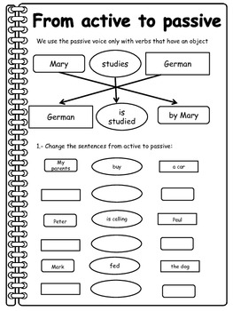
PRACTICE:

- Change the sentences from active to Passive:

A car
Buy
My parents
The dog
Feds
Mark

