ENGLISH CLASS
Passive and active voice
PRESENTE SIMPLE:

- Complete the sentences with the active voice, then pass them to the Passive.

- Many people…………..newspaper. (Read)
- The cleaner……………the door. (Close)
- The postman………….the letters. (Deliver)

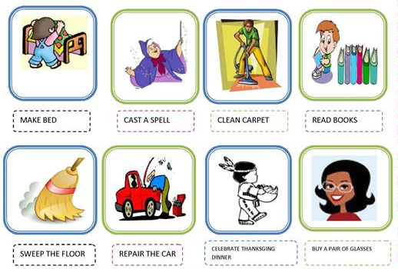
- Make sentences in Passive voice using the verbs and objects from each image. You can choose the subject.

