ENGLISH CLASS
Passive and active voice
PRESENTE SIMPLE:

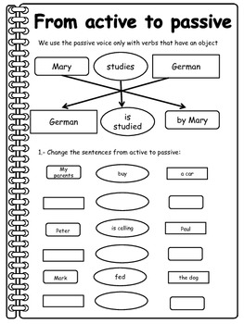
PRACTICE:

- Change the sentences from active to Passive:

A pink dress
wears
My mother
The race
Win
We

