English class
PRESENTE CONTINUOUS
TENSES:
Uso:
El presente continuo se usa para cosas que están pasando ahora mismo y para situaciones no permanentes.
Estructura:
Forma afirmativa
Sujeto +TO BE + verbo con –ING+ Objeto

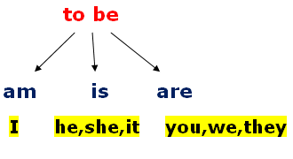

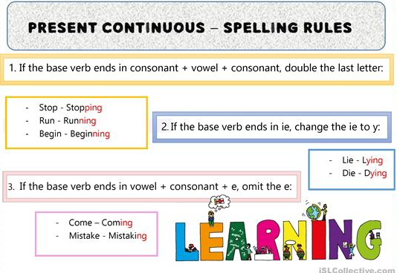
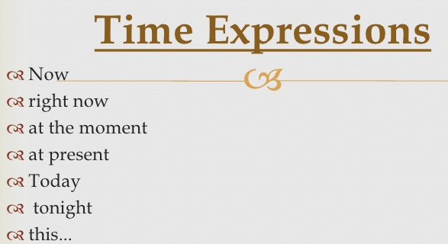

Examples:
- WE ARE PLAYING TENNIS TODAY.
- SHE IS WRITING A LETTER NOW.
- I AM EATING A PIZZA AT THE MOMENT.

PRACTICE
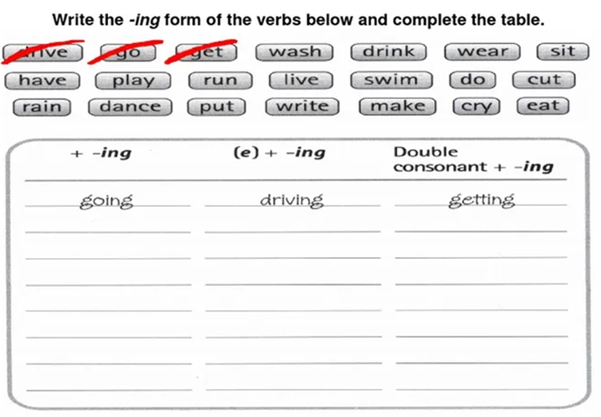

- SHE……………A CAKE NOW. (BAKE)
- I………………..A PIZZA TODAY. (EAT)
- YOU…………..OUR HOMEWORK AT THIS MOMENT. (DO)

