English class
PRESENTE SIMPLE TENSES:
Practice
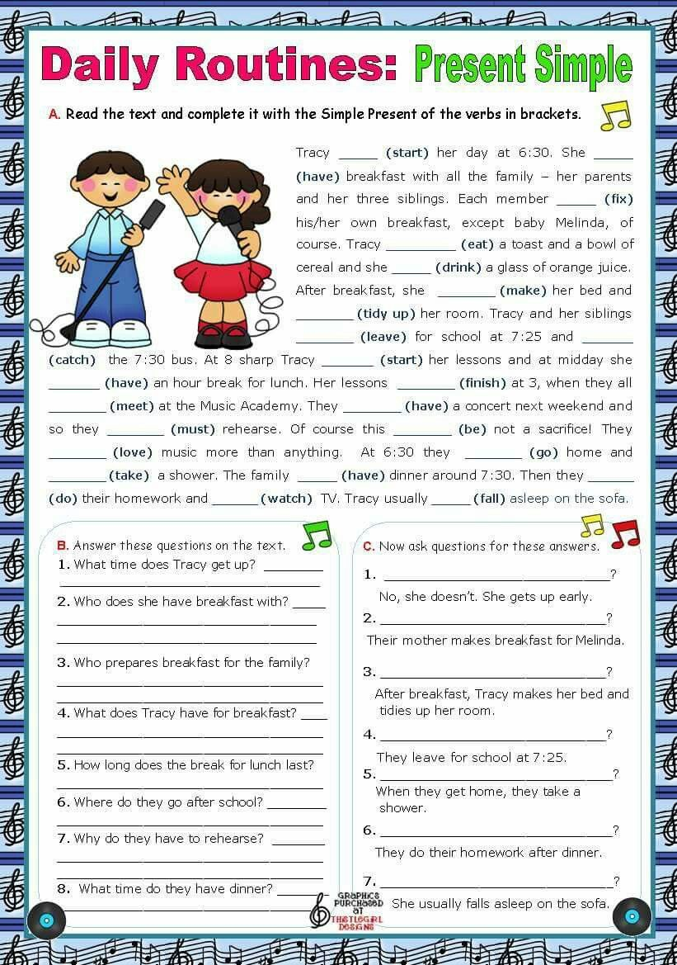
- Complete the text with the simple present of the verbs in brackets. Then translate it.

