English class
PRESENTE SIMPLE TENSES:
Practice:
- Watch this video:https://www.youtube.com/watch?v=t44Yb-i0TmM


- Complete these sentences with the verbs from the box :
GRU´S ROUTINES
DO – BE: IS - GET UP - EAT - HELP - CLEAN -GO
- HAVE (HAS) - DANCE - COOK

- a) Gru………………….at 8.30 in the morning.
- b) He …………… a shower and he ………………..his teeth.
- c) Gru …..……….breakfast and the girls …….…….Pancakes.
- d) Gru ……………very happy and he...……….…… in the street.
- e) He …….……… the ducks cross the street.
- f) Then, Gru ………………………exercise in the park.
- g) Finally, he …..……. to the shopping centre.

- Make NEGATIVE SENTENCES – Use DON’T. DOESN’T
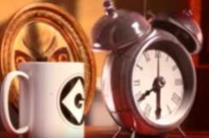
Gru wakes up at 7 o´clock -→ _____________________


He is very sad in the morning-→_____________________

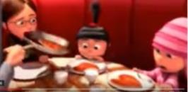
The girls make pancakes → _______________________________



Gru drives his car → ____________________________________

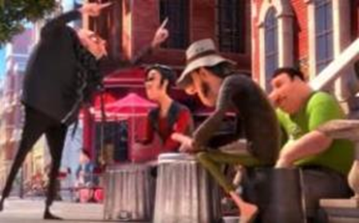

They play the guitar on the street→__________________________

- Answer the following questions:

- Does Gru have a shower? ……………………………………………………..
- Does he get up angry? …………………………………………………………
- What time does Gru get up? ………………………………………………….
- Where does he go at the end? …………………………………
- Who makes breakfast? ………………………………………..
- What do the girls eat? …………………………………………
- True or false


- Gru plays with a duck in the shower.
- The minions are in Gru´s house.
- The girls go to the park with Gru.
- Gru practises yoga in the park.
- He helps some dogs cross the street.
- Gru dances all the time.
- He walks to the shopping centre.
- Gru plays with a ball in the park.
- He buys some flowers.

