

Tecnicatura Superior en Desarrollo de Software

Inglés I – 2do Parcial

Name and surname: ………………………………….……………………………..…. Date: ………………………………………
- Lee el texto y realiza las actividades que se encuentran a continuación del mismo:
-------------------------------------------------------------------------------------------------------------
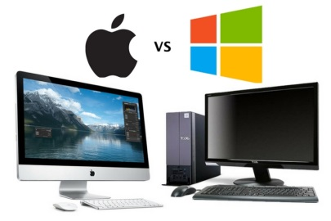
What is the difference between a PC and a Mac?
IBM invented the PC (Personal Computer) way back in 1981. All PCs released since then are in many ways compatible with the original design, though many extensions to the original design have been made. ³[The term PC compatible relates to PCs manufactured by companies other than IBM that are compatible with the traditional PC specification.]
¹[In the early days, most PCs ran an operating system called DOS (Disk Operating System)]. These days most PCs are running a version of Microsoft Windows (Windows 7, Windows 8, NT or Windows 10).
The Apple Mac is a computer, but NOT a PC. ²[It uses a different operating system, and requires special versions of application programs (such as wordprocessors or spreadsheets).] Even the hardware add-ons have to be customized to some extent to be able to be connected to a Mac. In the early days the thing that really distinguished the Mac over the PC was the GUI (Graphical User Interface), or in plain English the way you could use the mouse to drive the computer. In the early days of the PC, you really had to be a bit of an expert to use and maintain your PC!
Recently the differences between the PC and the Mac have blurred, with even Microsoft buying a stake in Apple.
--------------------------------------------------------------------------------------------------------------------------------------------------------------
- Con amarillo, resalta una construcción verbal en Presente Simple. _____ / 0,5
- Con verde, resalta una construcción verbal en Presente Continuo. _____ / 0,5
- Con gris, resalta una construcción verbal en Pasado Simple. _____ / 0,5
- Con celeste, resalta una construcción verbal en Presente Perfecto Simple. _____ / 1
- Subraya una construcción verbal en Voz Pasiva. ____ / 1
- Qué tipos de oraciones son las que se encuentran en el texto encerradas entre corchetes cuadrados enumerados: ¹[…],²[…],³[…] ? _____ / 1,5
- Responde en español las siguientes preguntas sobre le texto: ____ / 5
- Quién y cuándo se inventó la primer computadora personal?
- Qué significa la expresión ‘compatible con PC’?
- Qué sistema operativo utilizaban las PCs en sus inicios? Y cuáles utilizan ahora?
- Qué puedes decir de la Apple Mac? Brinda tres características.

Calificación final: _____ / 10

