Tecnicatura Superior en Desarrollo de Software
Inglés I
Tarea Nro 6

Name and Surname: ____________________ Date: _____________________________

Actividad 1: Une las oraciones directas (1-8) con sus mensajes indirectos (a-h) correspondientes.

1. The customer asks: “Is it an ink-jet printer?”
2. The customer says: ‘’I will take this monitor.”
3. Dick asks: “Ann, do you have a monochrome monitor?”
4. Alice says: “ I have bought a colour monitor.”
5. The Instructor warns: “Don’t sit too close to the screen!”
6. Peter recommends: “Consider this processor. It’s more powerful.”
7. Alan says: “ I can see dots on the screen.’’
8. The client says: “This is a flat panel liquid crystal display (LCD).”

a. The customer said he would take that monitor.
b. Peter recommended to consider that processor. It’s more powerful.
c. The client said that was a flat panel liquid crystal display (LCD).
d. Alice said she had bought a colour monitor.
e. The Instructor warned not to sit too close to the screen.
f. Alan said he could see dots on the screen.
g. The customer asked if that was an ink-jet printer.
h. Dick asked Ann wether she had a monochrome monitor.

Actividad 2: Traducir los mensajes indirectos al español.

Actividad 3a: Lee la carta dirigida a la sección ‘Derecho del Consumidor’ de una revista de aerolineas. Subraya mensajes indirectos.

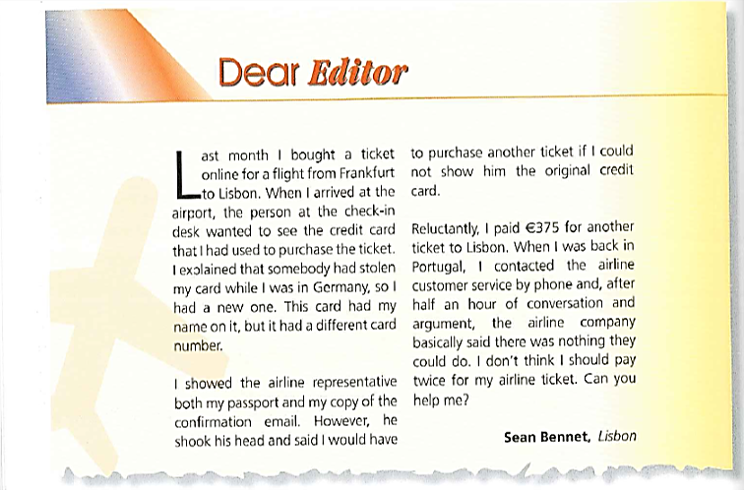

Actividad 3b: Lee la carta nuevamente. Realiza la lectocomprensión de las siguientes oraciones, y decide si las mismas son ‘correctas’ (“Right”) o ‘incorrectas’ (“Wrong”). Si no hay suficiente información para elegir alguna de las opciones anteriores, selecciona ‘no dice’ (“doesn’t say”).

a. The passenger had purchased the ticket with a credit card.
Right Wrong Doesn’t say
b. The passenger’s flight was with a German airline.
Right Wrong Doesn’t say
c. The names on the two cards were not the same.
Right Wrong Doesn’t say
d. The passenger had paid less than €375 for his original ticket.
Right Wrong Doesn’t say
e. He had to buy another ticket because he didn’t have a credit card.
Right Wrong Doesn’t say
f. The problem was solved by the airline customer service.
Right Wrong Doesn’t say

