TEMA 8: Present Continuous negative and questions:
Copiar el cuadro y realizar las actividades:
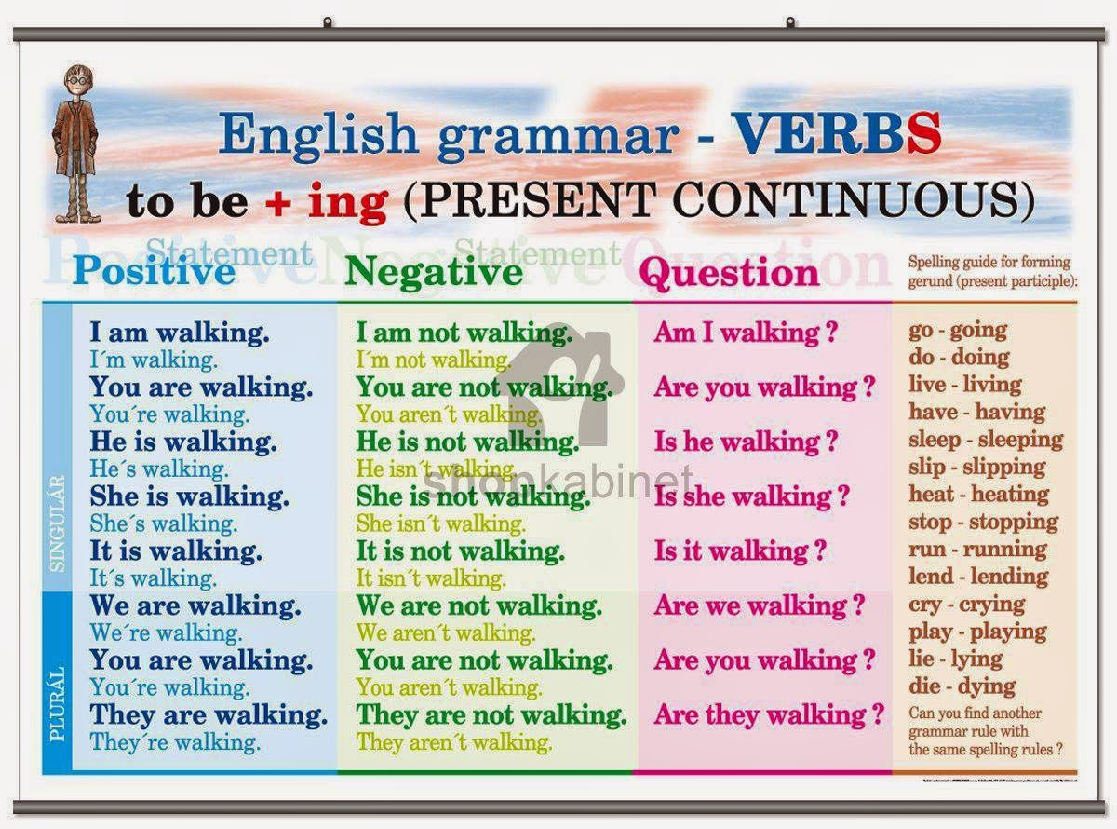
Completar las oraciones con AM /IS/ ARE y la forma ”ing“ de los verbos entre paréntesis.
- My sister…………………………. ( clean) the bathroom.
- Look! They……………………………… ( go) inside.
- I………………………… (wait) in the car now.
- Mrs Miller……………………… ( listen) to CDs.
- We ……………………………(speak) English at the moment.
Escribe el negativo del ejercicio 1.
…………………………………………………………………………………………………………………………………………………………………………….
…………………………………………………………………………………………………………………………………………………………………………….
………………………………………………………………………………………………………………………………………………………………………………
………………………………………………………………………………………………………………………………………………………………………………
……………………………………………………………………………………………………………………………………………………………………………
Escribe el interrogativo del ejercicio 1.
…………………………………………………………………………………………………………………
…………………………………………………………………………………………………………………
…………………………………………………………………………………………………………………….
…………………………………………………………………………………………………………………….

