ESTABLECIMIENTO
NOMBRE:
CURSO:
TRABAJO PRACTICO N°7: PRESENT SIMPLE Y ADVERBIOS
ADVERBS OF FREQUENCY ( ADVERBIOS DE FRECUENCIA)
Los llamados frequency adverbs son aquellos adverbios que sirven para expresar la regularidad con la que ocurre una acción.
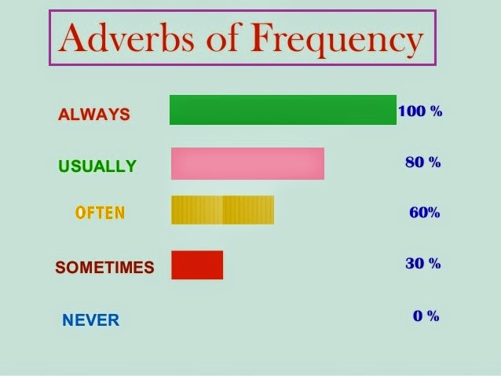

ALWAYS: SIEMPRE USUALLY: USUALMENTE OFTEN: FRECUENTEMENTE
SOMETIMES: A VECES NEVER: NUNCA

POSITION: (POSICION EN LA ORACION)
- BEFORE THE MAIN VERB. (ANTES DEL VERBO PRINCIPAL)
I ALWAYS WATCH TV.
verb
- AFTER VERB TO BE. (DESPUES DEL VERBO TO BE)
WE ARE ALWAYS LATE FOR SCHOOL.
Verb to be

Actividades: LUEGO DE LA LECTURA REALIZA LO SIGUIENTE:
1) Reescribir las oraciones usando los adverbios entre paréntesis.
- They listen to the radio. (often ) They often listen to the radio.
- They read a book. (sometimes)
- You get angry. (never)
- Tom and July are very friendly. (usually)
- She takes sugar in her coffee. (sometimes)
- Ramon and Frank are hungry. (often)

2) Escribir oraciones sobre ti mismo usando adverbios de frecuencia.

Always sometimes never often usually

1. get up at seven o’clock
____________I SOMETIMES GET UP AT 7 O’ CLOCK_______
2. have a shower in the morning
___________________________________________
3. have lunch at school
___________________________________________
4. do homework in the afternoon
___________________________________________

5. play computer games in the evenings
___________________________________________

3)Elegir la opción correcta para completar la oración.
I ___________ go to school on Sunday. (always/never)

She is a good student, she ___________ does her homework on time. (never/always)

Tom is lazy, he ________ forgets to do his homework. (always/never)

We _________ visit our grandparents on Sundays. They are not at home.
(sometimes/never)

4°4°: DANIELA CERDAN: danielacerdan@hotmail.com

