E.E.S N° 75
TEMA 5 Y 6 : REVISION PERSONAL PRONOUNS/VERB TO BE
LUEGO DE MIRAR LOS CUADROS DE PRONOMBRES Y VERBO TO BE REALIZA LAS SIGUIENTES ACTIVIDADES.
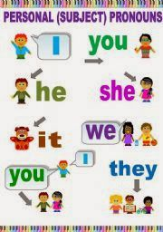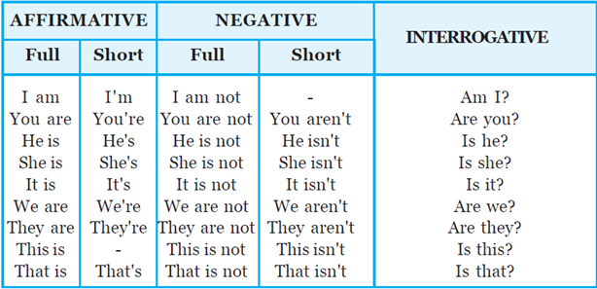

1. ESCRIBIR LA FORMA CORRECTA DEL PRONOMBRE PERSONAL:
A) ALICIA: …SHE…. C) ALICIA AND I: ……………………… E) A BOOK: ………………….
B) SAMUEL: ……………….. D) ALICIA AND TOMAS: ………………. F) BOOKS: ………………….

2. COMPLETAR CON LA FORMA CORRECTA DEL VERBO TO BE: AM – IS – ARE
A) I……AM ……. 13 YEARS OLD. C) WE ………………….. FRENCH. E) THEY ……………… FRIENDS.
B) SHE …………………. AT HOME. D) YOU ……………….. FROM BRAZIL. F) ANA …………………. 14 YEARS OLD.

3. PASAR LAS ORACIONES DEL EJERCICIO 2 A SU FORMA NEGATIVA:
A) …I AM NOT 13 YEARS OLD …. D)………………………………………………………………..
B) ……………………………………………………………… E)…………………………………………………………………
C) ………………………………………………………………. F)…………………………………………………………………...

4. ORDENAR LAS PALABRAS PARA FORMAR PREGUNTAS:
A) YOU / ENGLISH / ARE? ……ARE YOU ENGLISH? ……
B) THEY / STUDENTS / ARE?....................................
C)A TEACHER / IS / SHE? …………………………
D) FRIENDS/ ARE / WE? ………………………………………….

5. ESCRIBE EN LAS NUBES LOS PRONOMBRES PERSONALES QUE CORRESPONDEN A LAS 3 CONJUGACIONES DEL VERBO TO BE: I YOU HE SHE IT WE THEY
AM IS
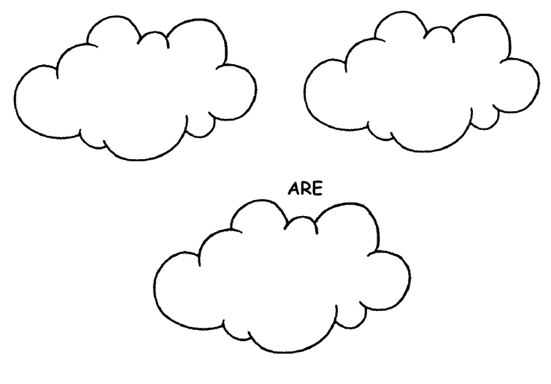
I

6. ELEGIR LA OPCION CORRECTA: (4,5 MARKS)

1) Sara [ am / is / are ] a teacher. | 6) His cat [ am / is / are ] black.
2) Jan and Sue [ am / is / are ] here. | 7) The students [ am / is / are ] sleepy.
3) I [ am / is / are ] at home. | 8) It [ am / is / are ] warm today.
4) A cat [ am / is / are ] soft. | 9) I [ am / is / are ] very busy.
5) My cat [ am / is / are ] gray. | 10) Watermelons [ am / is / are ] tasty.

